Identifying your sustainability impacts
As a department or team, identifying your most significant sustainability impacts will help you address issues that are specific to your area and will help prioritise the actions you’ll take in future. You can use the template on page 2 to record your impacts. Remember that sustainability isn’t just environmental – think about the Sustainable Development Goals that cover a breadth of sustainability issues including health and wellbeing, inequalities and communities.

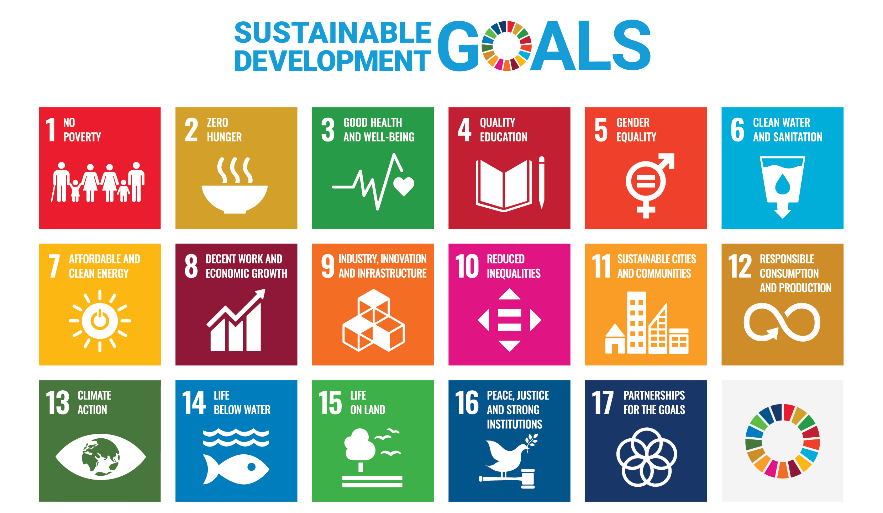

Firstly, start with your positive impacts. Perhaps you play an educational function, or your research helps achieve sustainability goals, or you help others with their sustainability improvements, or work with your local community. You may want to think about how you could expand, share, and celebrate these positive impacts further. Think about what your team does on a day-to-day basis – what your core functions are, what products you buy, how you travel etc.
Then think about your biggest negative impacts. The impacts could relate to energy use, waste produced, air travel by staff, car travel by visitors, the printing of publications etc.


Positive impacts

Positive Impact | Reason for its significance | Suggestions for ways to share good practice or increase your positive impact
1.
2.
3.
4.
5.


Negative impacts

Negative Impact | Reason for its significance | Suggestions for ways to reduce your negative impact
1.
2.
3.
4.
5.

