Information for new Green Impact teams
[Organisation name] is running Green Impact for the X year/launching a new programme and we want you to get involved!

What is Green Impact?
Green Impact is a sustainability awards and learning framework for teams across the organisation. It supports you to create positive sustainability changes within the workplace, as well as improve health and wellbeing, and connect with other teams working on their own sustainability.

How does Green Impact work?
Teams of staff form or join a Green Impact team and work their way through the bespoke online toolkit. The toolkit is made up of simple, engaging, and impactful actions for teams to complete throughout the year, as well as information to help you complete each action. The actions cover a wide range of sustainability themes, including energy, waste, water, and wellbeing.
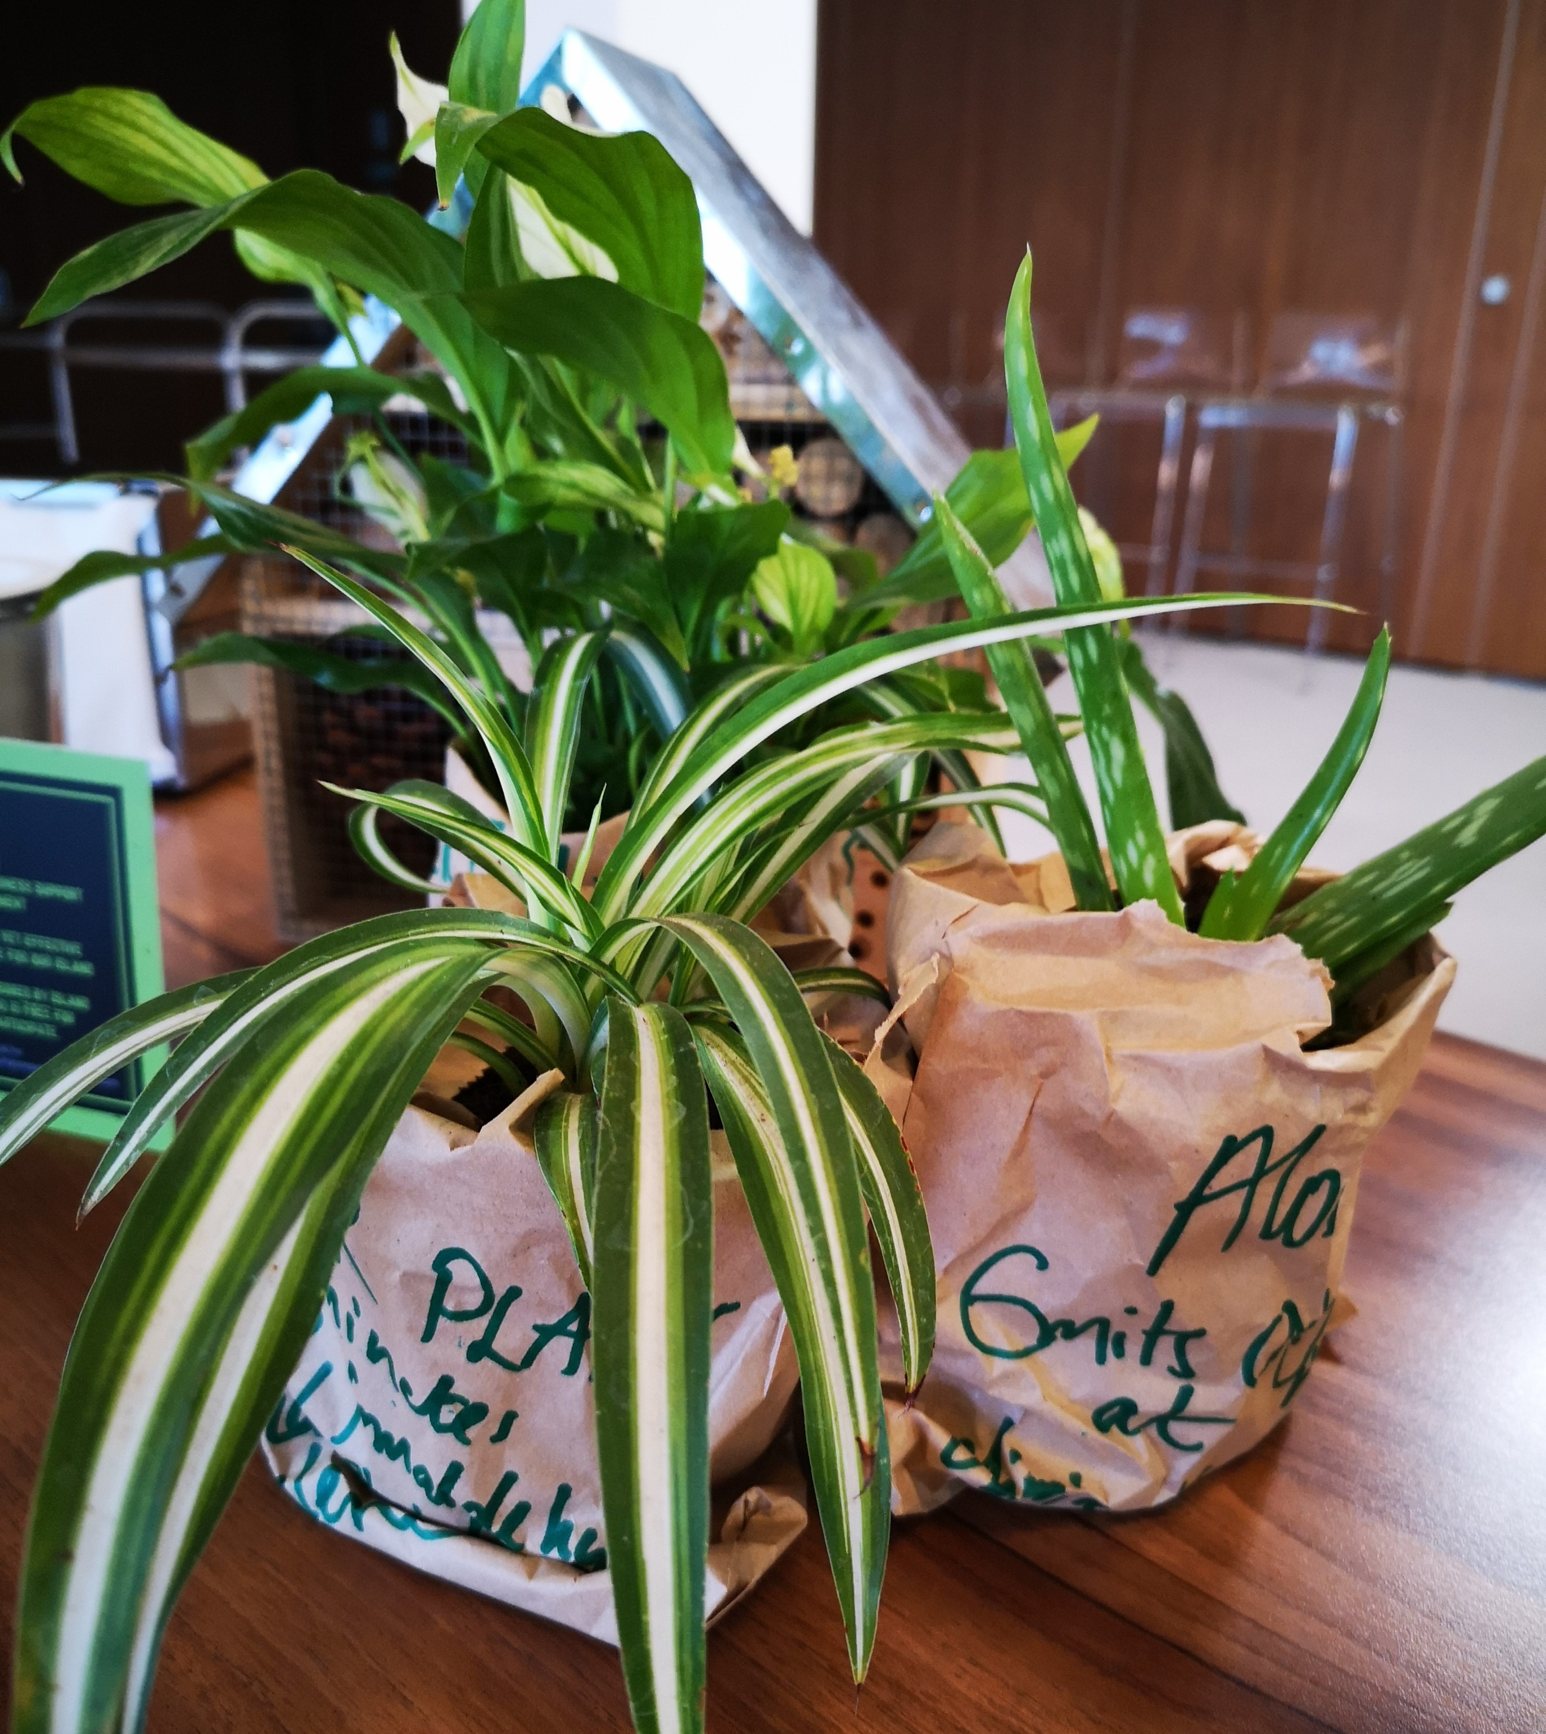

You’ll track your progress and upload evidence to the online toolkit, and at the end of the year will receive a student-led audit to verify the actions you’ve completed and determine which award level you will be presented with!

Will Green Impact be a lot of work?
Green Impact does not need to be a lot of work – as little as half an hour a week depending on the level of award you are going for and the size of your team. You’ll have approx. 9 months to complete the actions and there will be lots of support available along the way. Even if you only complete a few actions, you’ll still achieve ‘working towards accreditation’ certificate, so there is nothing to lose!

Why should I get involved?
Green Impact is simple, fun, and rewarding. By participating you’ll get to:
- learn more about sustainability issues,
- network and share ideas with new people from both within and outside of your organisation,
- build professional and personal skills,
- help make the organisation a more sustainable place to live and work,
- be recognised for positive actions you are doing already,
- utilise a bespoke framework to help you achieve positive change within your workplace,
- encourage colleagues to think about sustainability in new and innovative ways,
- benefit from the shared experience of thousands of others across the world who also use the Green Impact programme,
- achieve recognition at the awards ceremony,
- do something a bit different from your day-to-day role and have some fun!

How will I be supported?
You will be supported by staff at the organisation as well as SOS-UK, who run the Green Impact programme nationally. Throughout the year we will be holding a number of activities where you can build your understanding of sustainability, ask questions, and share ideas with other teams. You’ll receive regular communications to help you, and you can get in touch at any point if you need some extra support – all the contact details you’ll need are provided in the online toolkit.

You can also register for a Green Impact Project Assistant, a trained student volunteer who can help you throughout the year.

What awards can be won?
At the end of the year all teams will be presented with an award to showcase their progress. There are Bronze, Silver and Gold awards available, depending on the reach and impact of your work. The online toolkit outlines what you need to do to achieve each award level.

How do I get involved?
- Head to www.greenimpact.uk/X, click ‘Register’ on the right-hand menu, put in your details and verify your email address. If you already have a team set up you can join your team when prompted, or you can set up a new team.
- Encourage colleagues in your team to join your team and register themselves in the same way.
- Meet with your team to decide which award you are going to go for, and what your sustainability priorities are.
- Work through the actions in the toolkit, marking them as done, and uploading comments and evidence along the way to keep track of your progress.
The deadline for this year’s Green Impact cycle is X so make sure to get all your actions completed before then!

Any further questions?
Contact us at [insert details] or visit [website URL].

