**YOUR LOGO**



This is to certify that

**Do something different at work and get involved in Green Impact 2017-18!**

Have some fun whilst making positive changes to your department and the wider university, engage with new staff, learn new skills and gain recognition and awards for your hard work!

Contact [XXXXX@XX.ac.uk](mailto:XXXXX@XX.ac.uk) for information on how to get involved!

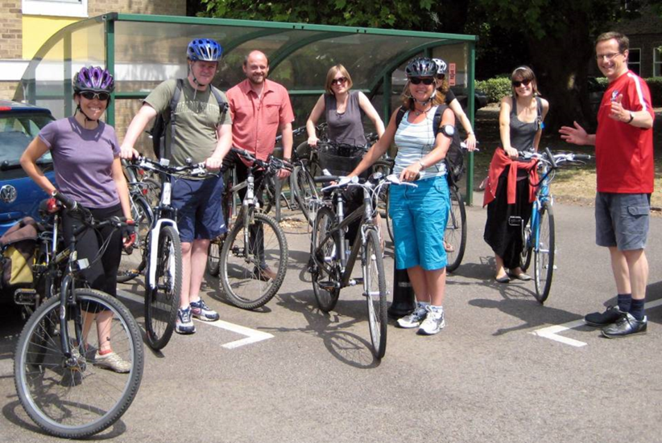 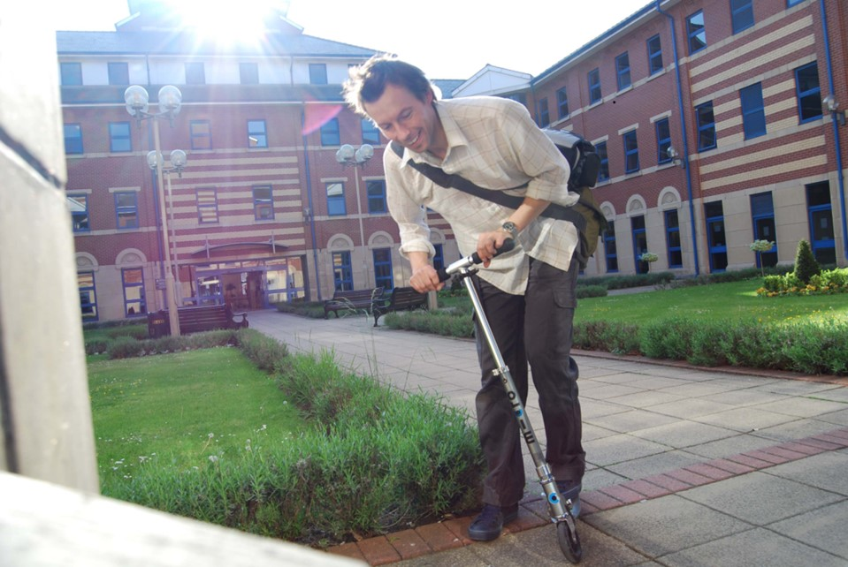 

**YOUR LOGO**