Green Impact Auditing – what’s in it for you?
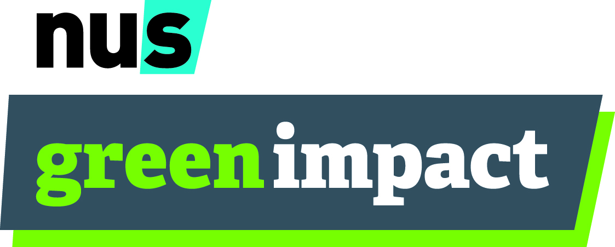

Engaging students and providing opportunities is at the heart of Green Impact and getting you guys involved is pivotal to programme success!

You can get involved by becoming a Green Impact Auditor, which involved visiting teams alongside fellow students to accredit the work they have been doing as well as provide feedback and inspiration for future projects.
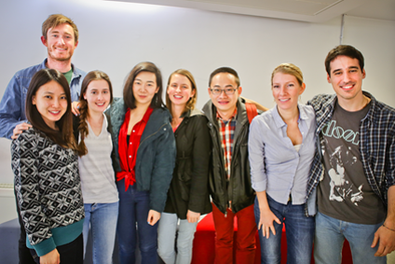
Here’s the perks at a glance:
- No previous knowledge is needed
- Takes place over just one day
- IEMA approved training and experience in environmental auditing

Here’s the benefits:
- Free IEMA approved training
- Fantastic CV experience all for just 1 days work
- Gain experience in environmental auditing
- Learn and develop great skills such as team work, organisation and time management
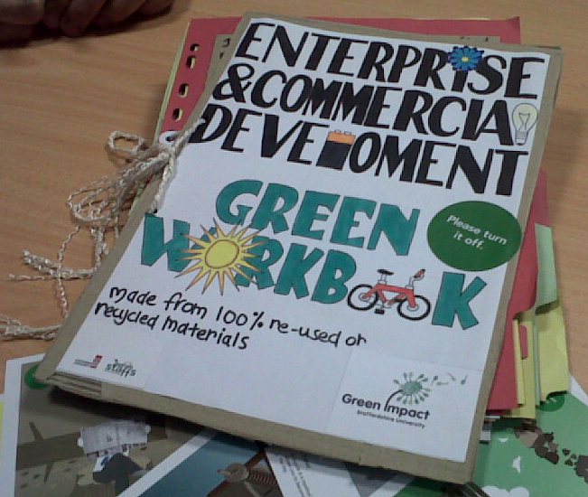
- Get involved in something new and innovative
- Have some fun!
- Meet new people and likeminded students
- Be a pivotal part of the programme
- Make a difference to your campus and the environment
- See first-hand some of the great sustainability work taking place on your campus
- Visit different university departments and explore new areas of the campus
- Help staff make changes and provide new ideas, insight and student perspective
- Gain knowledge of implementing sustainability actions in the workplace
Take Part!

Your Audit date is XXXX

Sign up today to take part by emailing XXXXXX or sign up here XXXX

We look forward to meeting you!

