GREENIMPACT
CARES GUIDE 2019

Green Impact is the University’s environmental accreditation scheme, it supports and encourages departments to reduce their environmental impact and make the workplace greener. Read on to find out what we can do in CARES.

Why do we run Green Impact?
We know students care about sustainability.
80% of students want their institution to be doing more on sustainable development. The scheme also has a huge impact - last year the University saved an estimated 75 tonnes of CO2 and financial savings of £26,033.
The benefits:
Last year 643 colleagues took part in Green Impact. When you join an existing team or form a new one you’ll be helping the environment and yourself:
- Help us reduce our environmental impact.
- Develop in your role and work in new ways.
- Network with colleagues.
- Attend the Annual Awards Dinner

SAYNOTOSINGLEUSE
Seven million disposable coffee cups are thrown away every day in the UK. We can play a part in reducing this figure by the recycling and reduction of single-use coffee cups.
The best way to reduce impact is to ditch the disposable cups and fill up your reusable cup. Our Beckett Food reusable cups are just £5.50 and your first drink is free. Even better - each time you bring your reusable cup we’ll take 20p off your hot drinks!
Forgotten your cup? There are several bins around campus specifically for disposable cups, or you can use the Revending Machine in the Rose Bowl and get a voucher 20p off your next purchase in our outlets!
Look out for other opportunities to reduce and recycle across CARES, from using food waste bins to seperating your recyclables!
Who is already involved?
So far 6 teams from CARES have signed up and together we have already completed 101
actions! The teams are; CARES City Cleaning and Portering Group, CARES City Food Services, CARES Headingley Cleaning & Portering, CARES Queen Square House, Cares Headingley Food Services.
How to take part:
It’s not too late to join, so if you’ve been inspired to join Green Impact then get in touch with a colleague from your local team to find out more about getting involved or speak to ur Green Impact contact.
If your area doesn’t already have a team, why not set one up?

REDUCINGOUR ENVIRONMENTALIMPACT:
Every member of CARES has an important role to play in reducing our environmental impact. To see how you can help, take a look at our handy checklist below:

Meet Digitally
Instead of travelling to meetings, try to hold your meetings through video-conferencing such as Skype, if you’d still like to step away from your desk try booking one of our video conferencing suites.

Stationery
When ordering stationery with Office Depot, check out their ‘Green Office’ ethical products which have been produced in a more environmentally friendly way.

Save Your Stamps
Many charities can trade in used stamps for donations - choose a charity and save your stamps!

Visit: reducereuserecycle.co.uk
Posting Documents
Need to send an item by internal post? Stop and think, could this be sent electronically instead?

Paper Waste
Scan documents rather than print. Think twice before printing, do you really need to print that document? You can also reuse waste A4 paper if it’s printed on only one side.

Save Energy
Switch off your lights, printers, PCs and other equipment when not in use.

Post-it Notes
Reduce your usage of paper by making digital notes.

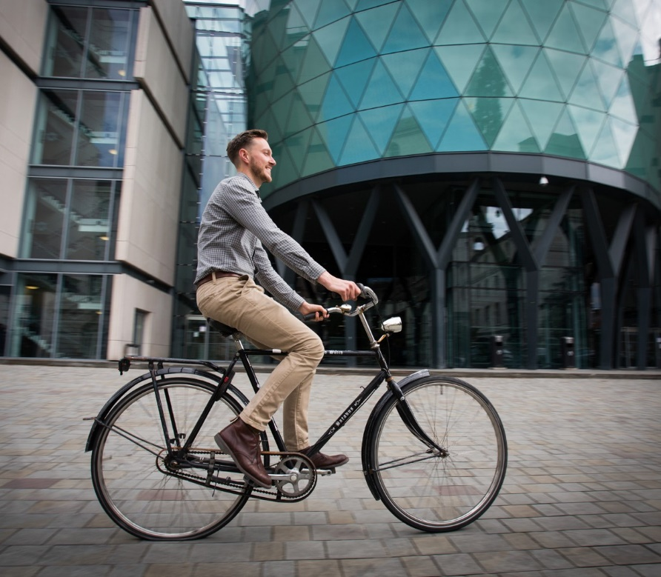
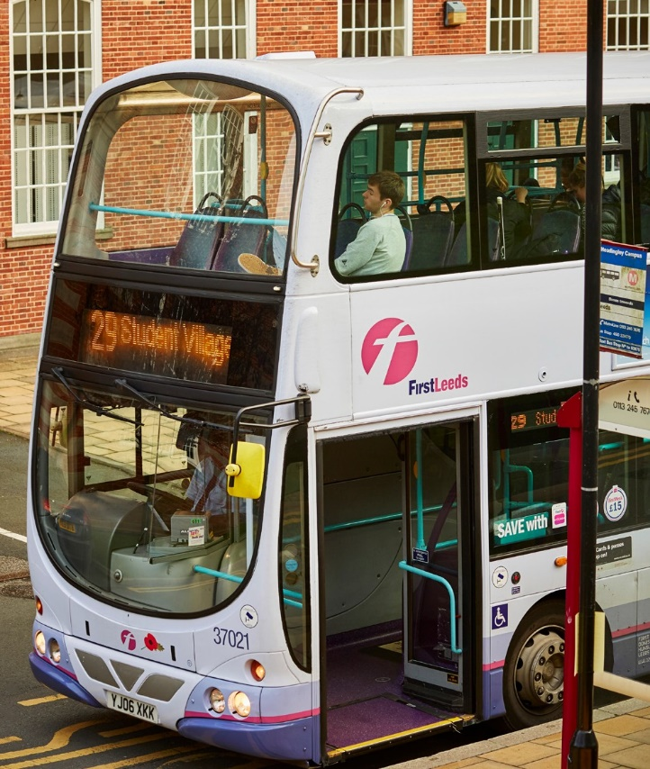
TRAVEL& TRANSPORT

CYCLINGFACILITIES
We have a range of facilities for cyclists, including; cycle parking (sheltered and secure storage available), showers and lockers.
There is also a BikeFix maintenance workshop as well as the BikeHub, a shared facility with the University of Leeds.
Visit: leedsbeckett.ac.uk/staffcycling

BORROWABIKE
If you can’t bring your own bike into work but would still like to use one to get around, then you can borrow one of the two folding bikes!
Book it: beckettsustain.simplybook.it

HIREANELECTRICBIKE
Try using one of our electric bikes to commute between City Campus and Headingley Campus. It’s a great way to keep fit and get some fresh air during your working day, and of course you’ll be helping the environment too. It’s easy to book by visiting the link below and they can be hired for up to 2 weeks.
Book it: beckettsustain.simplybook.it
More info: transport@leedsbeckett.ac.uk

WALKINGROUTES
Whether you’re commuting by foot all the way, getting off the bus a stop or two early or planning a lunchtime walk, you can plan your route using Walkit. Find the fastest route possible or take a scenic detour by filtering by the ‘Nature’ or ‘Architecture’ options.
Visit: walkit.com/cities/leeds

STAFFBENEFITS:
Visit: leedsbeckett.ac.uk/partners/ employee-benefits/travel-transport-benefits

Bus and Rail Cards
Make use of the university’s interest-free loan scheme to buy travel passes - you can save up to 12 weeks travel per year! Passes included are; First bus passes, Metro Cards and Northern Rail season tickets.

Cycle to Work Scheme
If you cycle to work more than 50% of the time then you can hire bicycle equipment through the universiy’s partnership with Cyclescheme.
More info: info@cyclescheme.co.uk

ETHICAL& ENVIRONMENTALLY FRIENDLY BUYING

FASHION
With the fashion industry being
the second biggest polluter in the world, many fashion brands are now stepping up to combat textile waste.

Retailers such as H&M and Marks & Spencer have textile recycling bins in their stores, and will trade a bag of your old textiles for vouchers!

FURNITURE
Why not try upcycling a
second hand find, try treausre hunting at your local charity shops, vintage fairs, Facebook Marketplace, Shpock, Ebay, Gumtree and of course our Leeds Beckett Classifieds List!

When it comes to wood products look out for the FSC logo which guarentees the replacement of harvested trees.

Check out our guide below on how you can make more ethical
purchases at work and at home.

KEEPITCLEAN
Look out for cleaning products

FAIRTRADE
When it comes to sourcing
ethical and environmentally friendly products, the Fairtrade accreditation is a big one.

Products with the Fairtrade symbol have ensured the price for the product gives fair wages, decent working conditions
and fair terms for the workers and farmers, which in turn increases sustainability.

FOOD
Alongside Fairtrade, look out
for specific food accreditations, such as The Soil Association, Rainforest Alliance, Red Tractor Food Standard and MSC Certified Seafood.

Buying locally not only supports local businesses but there is also a reduction in the amount of miles the product has travelled.
that are organic or cruelty-free, or have a go at making your own!
Visit: ethicalconsumer.org
a great online resource with lots of tips and advice for being an ethical consumer.

Good Money Week
Set up by UKSIF to raise awareness of sustainable, responsible and ethical

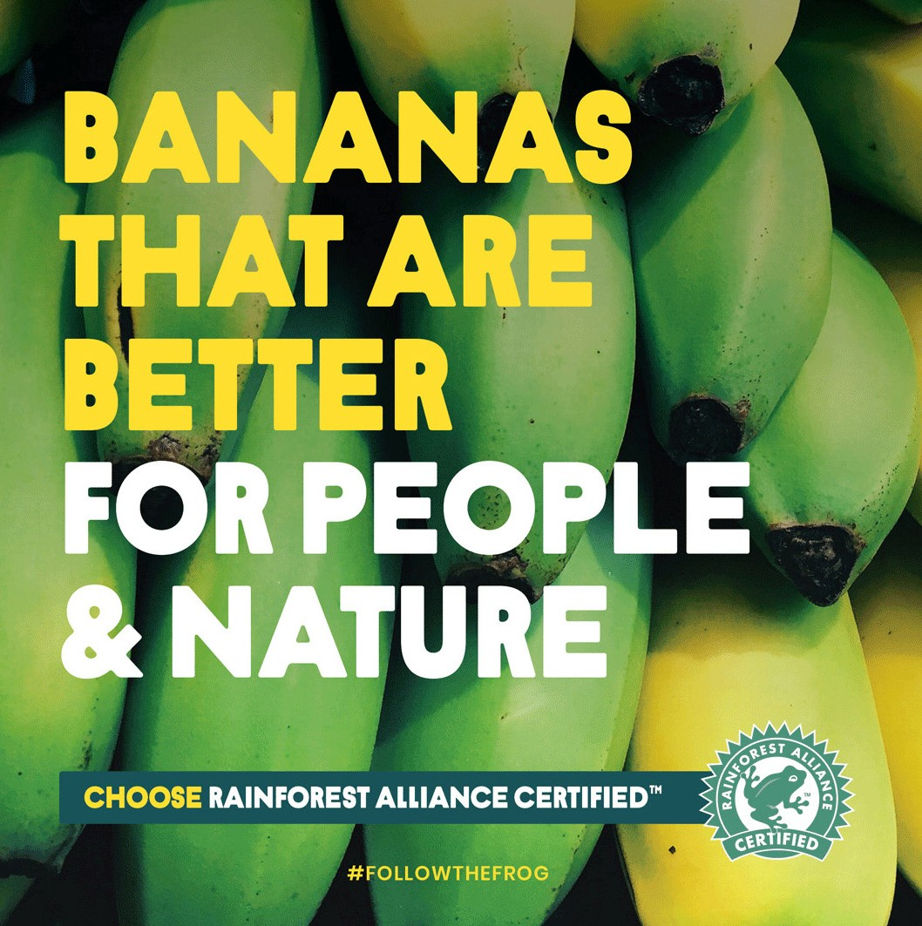

FOLLOWTHESUSTAINABILITYTEAM
Visit: leedsbeckett.ac.uk/sustainability

m
finance (banking, pensions
savings and investments) to help you make good money choices. This year it’s 5 - 11 October 2019.
Visit: goodmoneyweek.co
/beckettsustainability
/beckettsustainability
@BeckettSustain

