Supporting your Teams

As with any team project a groups’ motivation will peak and trough. As the project lead there are lots of proven methods that you can use that will help to keep your teams happy. Teams have been known to go off the radar and then appear near the end having completed lots of criteria. Provided that you are regularly in touch with your teams and they know how to contact you, you will be amazed by how many actions they will complete!
“The Green Impact scheme has had a great impact on myself and many of my colleagues and students. It has been life changing!” University of Winchester Team Member

Workshops
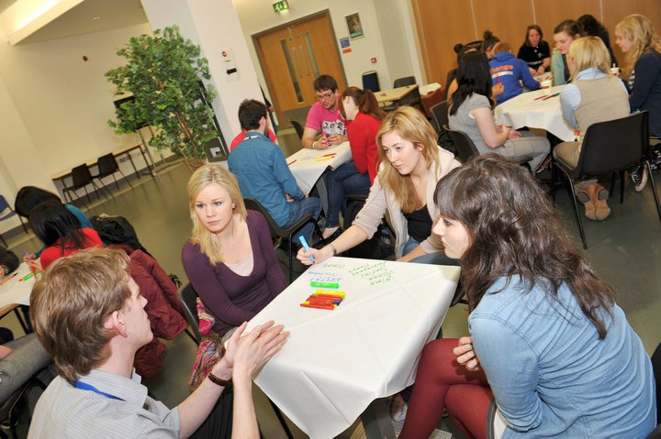
Running workshop sessions is a really great way to build a Green Impact community, encourage teams to share their experiences, as well as an opportunity for you to pass on your pearls of wisdom. Whether you focus the session on getting people started, team building, planning their SMART action plans, or as support sessions later in the year, huge benefits will come from getting everyone in one room. When you are planning your workshop make sure you find out what teams need help with, think about what’s coming up and give yourself lots of time to advertise it. Planning it around an up-coming event, i.e. Fairtrade fortnight or Power week, can help motivate teams to get going with time constricted criteria.
Staff and student sessions at QUB

It can be worth bringing in a person from outside of your organisation to boost morale and add variety. Your GI Project Officer will be more than happy to come and run a session for you and will have some standard workshops they can deliver if you book them in with enough time! Lunchtimes sessions are always a good time to catch people with limited availability. Alternatively for those just starting out with fewer teams why not use a free service such as Doodle poll to determine when is best to hold your session.

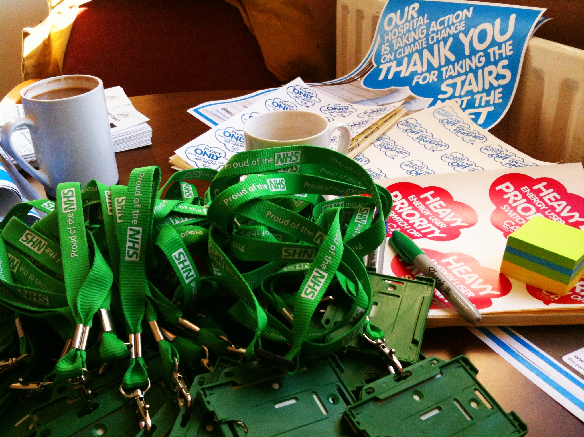
Visits, drop-ins and coffee mornings.

At least once during the year it’s a good idea to put a little time aside to go and informally visit your teams. Drop ins and visits can be great alternative to workshops if you have low attendance to these events or if teams have limited capacity. It will really help to make the teams feel supported, put a face to the name that sends all those emails and will make teams feel more comfortable to contact you with any future problems.
University Hospitals Bristol had stands in key places around the organisation giving advice and resources
Similarly, setting up a regular time and place where teams can come and discuss any issues that they are having can be a really useful method for engaging your team members. Send around an email or calendar invite a couple of days before. Then on the day follow up with an email and some social media activity i.e. a Facebook post and a tweet either before you arrive or when you are in location saying something along the lines of “All set up at the main building foyer for the #GreenImpact drop in session, I’ll be here until 2pm come say hi”, it’s always good to include a picture of yourself with the stand so that teams know who they are looking for. Then all you have to do is sit there, while getting on with some work, and see if anybody turns up. If you’ve got lots of buildings or sites in different areas it may be worth rotating your drop-in location.
Monthly coffee morning meetings have proven to be really great way to create informal drop-ins and build a GI community. Due to the more social nature of the event it is easier for teams to chat to each other establishing a GI network. This time can be used to update participants on any upcoming events and provide support for any criteria they are struggling with, and provides an opportunity for teams to bring along examples of work they’re particularly proud of to share with others. Just don’t forgot to provide the tea, coffee and (if you budget allows) cake, to ensure happy participants. You could also encourage new faces to come along by suggesting teams ‘bring along a friend’ to gain bonus points!

Phone arounds

If it’s proving difficult to meet in person with your teams, schedule in phone arounds periodically throughout the months of the Green Impact year. You may notice from your local admin reports that some teams aren’t yet ticking off actions on the workbook, be proactive and give them a ring to find out what difficulties they’re experiencing, could you help by facilitating their first green impact team meeting or perhaps some resources such as the energy walk around checklist to help them get going with a practical action.

You may want to use NUS support for your Project Officer to schedule in some of these phone arounds, speak with them early on in the year to plan when this would be most appropriate and the process for feeding back team comments.

Making it Fun
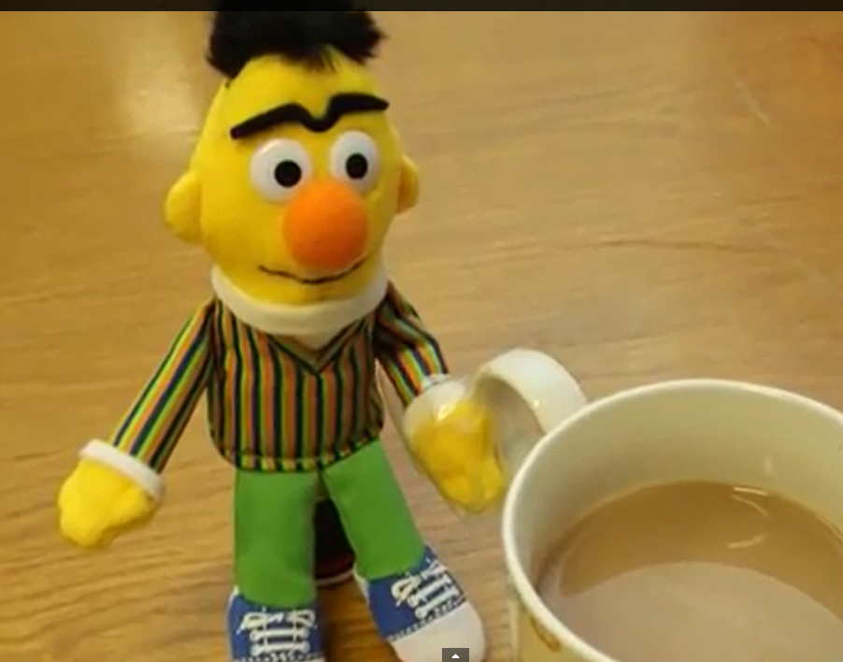
Taking part in Green Impact should be an enjoyable and rewarding experience, so remember to find opportunities for fun ways of raising awareness of the environmental agenda.
- Learning new things together: growing veg or potted plants in the office, cycling to work together, sharing eco films, campaigns such as Fairtrade Fortnight
- Have competitions: Fairtrade bake off, green pop song/film title competition, eco-come dine with me, guess the amount of energy used/photocopies made, chilli or pea growing contest.
- Make use of skills: Photography, web design/blog creation, sponsored run/cycle for charity, musical talent – here is a great example that a team in Sheffield University put together.
Fun and engaging video by a Sheffield University Green Impact team
- Use prizes: Hold a criteria of the week photo competition, or run a ‘Power week’ rewarding those who complete the most actions in a week with a prize and a mention in the Green Impact newsletter.

Newsletters
Creating a newsletter is a great way to organise your info in one easy to find place. The Green Impact team will send regular national updates, and some of these stories along with local updates will be a useful tool for the team leaders to share with their wider green impact departmental group. If you are not already signed up to the newsletter, please contact sustainability@nus.org.uk You may consider having different group mailing lists so you can target communications accordingly (e.g. new/established teams, office/labs teams).

Team Mentoring
If there are experienced and confident teams participating in your programme you may be able to set up a mentoring or buddy network to encourage teams to support each other and facilitate peer to peer learning. You may want to connect teams based on proximity to each other, experience on a particular issue (e.g. engaging students) or opportunity for collaboration (e.g. joint event/newsletters).

Make sure your newsletter is forward facing as well as backwards looking. The newsletter is a great way of maintaining momentum and enthusiasm among your team members throughout the year. Keep them coming as regularly as you can, and liven them up by:

- Playing on the competitive element between teams by publishing new innovative ideas or a leader board.
- Publish/recognise winners of small competitions you have run, such as of the criteria of the week photo competition
- Have a team profile of the month for readers to get to know other participants across the organisation
- Information about the organisation’s eco decisions and the wider impact their actions are having
- Publicise Green Impact or local sustainability events
- Environmental promotion details
- Run quizzes and smaller competitions – Christmas quizzes are pretty popular across our organisations
- Split it into the themes of the workbooks so it is easy to follow and works in line with the programme
- Have a ‘criteria of the week’, here you can mention time restricted criteria, such as those in the lead up to Fairtrade fortnight.
- Highlight what the SU is achieving in their Green Impact programme

Websites
Our Green Impact website (www.greenimpact.nus.org.uk) is the first natural point of call for people looking to find out more about the scheme. However, it is really important that your organisational website/intranet is clear, concise, enticing and up to date with local information - how directly you can edit and shape the content will vary from organisation to organisation.

It’s important, then, to give a brief overview of how the scheme works, and how the year unfolds – making it sound exciting and achievable of course! Don’t forget – this is a form of sales pitch, so be sure to highlight the numerous benefits of Green Impact, both to the organisation as a whole, and to the individuals involved. It’s also vital to ensure that there are easy to find current contact details on the website to ensure that people can reach you should they have a query or want to become involved in Green Impact.

Here are some examples of Green Impact websites:
- Sheffield University have a dedicated Green Impact website, this one-stop-shop has everything teams need to complete GI.
- York University’s Green Impact webpage uses tabs so that viewers can easily locate the information they need.

Social Media
Social media is a brilliant (and fun!) way of reaching brand new audiences who may not have heard of Green Impact at your organisation before. The two foremost platforms which you might want to engage people through are Facebook and Twitter. We have created some guides about how to set up Facebook fan page and start a Twitter account here, there are also lots of other free tutorials on the internet. Have a look at the examples below of Green Impact social media pages from the University of Sheffield and their Union. Be careful not to neglect any social media accounts you might open. It is better to post regularly once a week than it is to have sudden bursts of activity once every month or two. It is also very effective to engage with other related Facebook and Twitter users/accounts (most Students’ Unions will have an account, for example, or other local green initiatives) to reach pockets of people who might be new to Green Impact. Above all, Facebook and Twitter are two great ways of instantly sharing photos, ideas, stories, news and inspiration – a fantastic way of expanding your audience and pool of influence.

