Awards Ceremonies

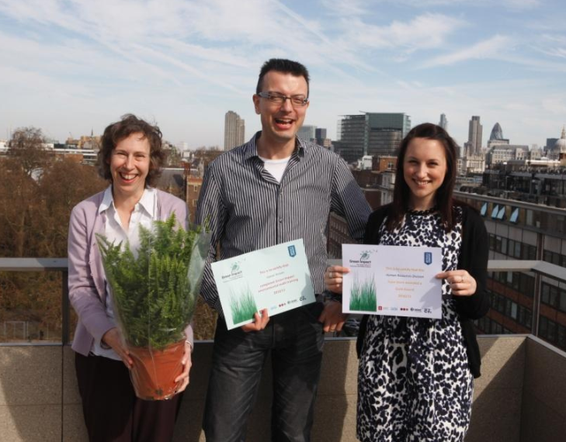
One of the greatest highlights of the Green Impact year is the awards ceremony. These celebrate the achievements made by every team and individual throughout the year. It’s a great opportunity to reward improvement from previous years or to highlight the organisation’s progress. They act as a great PR opportunity and a way to raise awareness of the programme, its wide reaching benefits and to secure its progress in future years.

What to Consider?
Every organisation’s awards ceremony is unique! We’ve seen everything from picnics in the park to grand sit down dinners. The only pre-requisite is that your awards ceremony should provide each participant with the opportunity to be recognised for their efforts, and instil a sense of cumulative achievement that they can take forward and into their own lifestyles.
LSE Gold Winners
Date
You should have decided this earlier in the year and logged it in your project planning document. Please ensure that as a minimum it is 6 weeks after the audits take place. Make sure it doesn't conflict with any other major events, though if you can combine it and therefore make use of an already high profile occasion then that can work well. Ideally try to ensure it is at a time of year when your student auditors or project assistants can attend and for universities and college invite your Students’ Union too, as this can add a real element of excitement to the event and gives you a chance to recognise their involvement and achievements too. Booking a date early means you are more likely to get high profile staff members (such as the VC or CEO) and ensures that a nice room is available, saving a lot of stress!

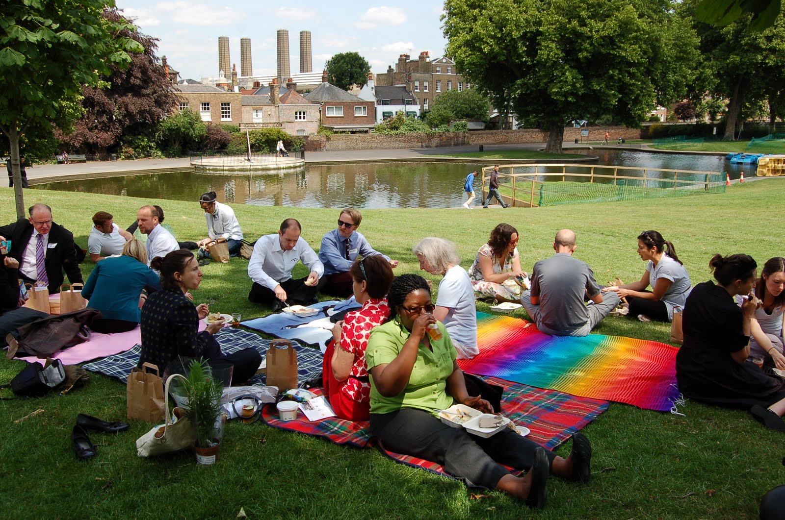
Venue
Greenwich University’s picnic award ceremony

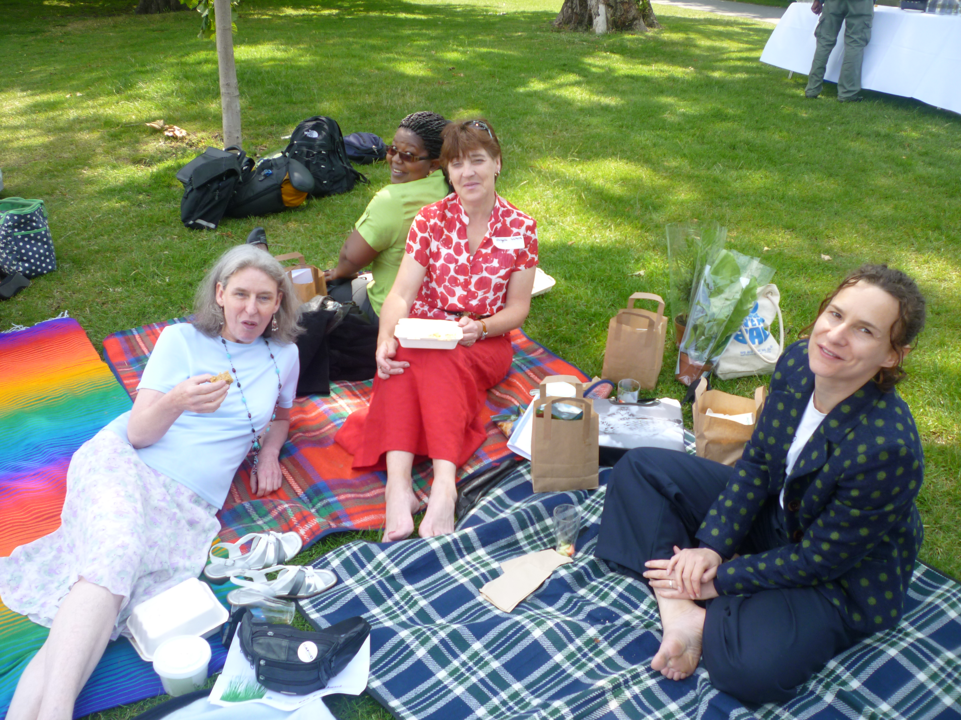
The venue is the best place to begin planning your awards ceremony as it will set the tone for the event. If you are going for a formal event try and find a prominent room that’s large but that won’t swamp the number of people attending. For less formal events you can be as creative as you like, award ceremonies have been hosted in botanical gardens or other open spaces. Some organisations have also held their awards ceremonies in their local student’s union, demonstrating collaboration between the institution and the students’ union on the environmental agenda.

Invitations
The greater the number of team members and senior member(s) of staff present, the more publicity the event will gain. Senior management support will communicate clearly that environmental issues are taken seriously by the organisation. People to invite include:
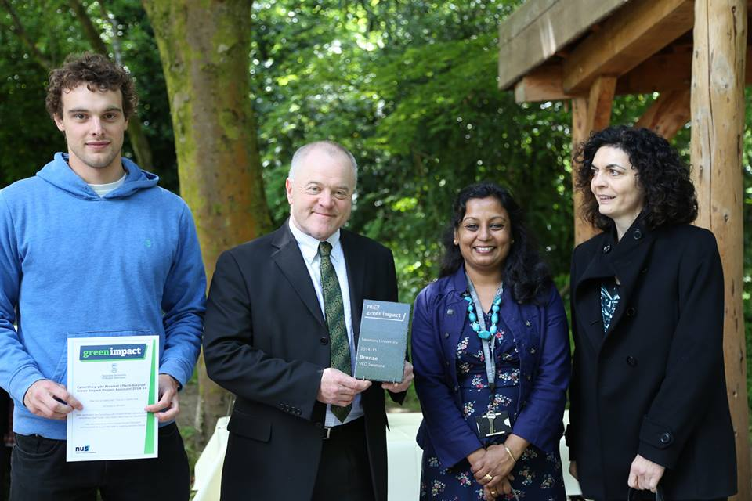
- Departmental Green Impact leads and their teams – consider asking one of them to speak at the ceremony – it’s great to have someone on the ground talk of their experience!
Awards ceremony at Swansea University
- Senior members of staff/the Vice Chancellor/the CEO
- Student and staff volunteer auditors
- Local students’ union staff and officers
- Key members of supportive staff (marketing, estates etc)
- External stakeholders
- The NUS Green Impact Team! One of us is always keen to attend and can speak, present or simply help out. Alternatively we are always happy to send you a recorded video or even Skype in on the day!

One really useful tool for managing this process is eventbrite; a free online ticket selling website. Visit eventbrite.com to find out more.

Running order
It is important to plan ahead how the ceremony will run and who will take on which role. Here are a couple of things you need to consider:
- Master of Ceremonies - Make sure that you have organized a master of ceremonies for your event and have briefed them fully. As the organiser you may decide to complete this role but if you think you’ll be busy ask someone else.
- Reception - Give some time either at the start/end of the event for staff to mingle and network with each other
- Guest speakers – at what point do you want them to say a few words? Ensure that they are fully briefed of what you expect them to do.
- Awards collection – see next section for further info.

Have an agenda that you can circulate to participants, in particular to speakers so they know when it’s their turn, prior to coming to the event.

Awards Collection

Considering how people will come and collect their awards is really important for ensuring that the event runs smoothly. Particularly in the case where you have lots of teams, giving out awards individually can take a long time. Consider the following points:

- What will you place the awards on? Don’t forgot to book out a table and bring a table cloth if necessary.
- What is the best way to setup the room so that teams can collect their awards as quickly as possible?
- Would a seating plan help where all teams are sat in order similar to a graduation ceremony?
- Could you have groups of individuals collecting awards at the same time, such as all bronze winners at once?
- Will having a photographer at the point of receiving the awards upset the rhythm of the awards presentations? If so consider getting categories (i.e. all Bronze, then all Silver, then all Gold teams) up at the end.
Photography and Film

Capturing the moment of teams receiving awards is an important moment for your teams to have their time to shine as well as a chance to collect materials to advertise your organisations. Consider:
- Do you want a backdrop for the photos? The Green Impact Team can provide a banner but will need to be given a few weeks’ notice.
- Whether to have photography and filming during the ceremony? This can sometimes disturb the flow of events so make sure you manage this well if you decide to.
- Whether to have a photo booth outside of the awards presentations?
- Would you like to get video clips of the teams talking about their experiences?
- Could you get footage to help with a general sustainability video you’re putting together, see this great example from Kingston University
Sit down dinner at University of Leeds
- Could you send out team photos to remind them of their Green Impact successes?
Refreshments

Providing refreshments is a great way to encourage team members to attend the awards ceremony and make them feel special. Make sure that your catering reflects Green Impact’s ethos by using locally sourced, seasonal and Fairtrade tasty treats. It is also essential to ensure that you do not use disposable plates, cups and packaging.

Depending on your budget, you might simply opt for tea and cake, or if you have more to spend, a finger buffet is often a nice touch. University of Leeds have previously treated their participants to a three course dinner!

If you are running a lunch time event, it is worth providing some light lunch for those attending.

Awards
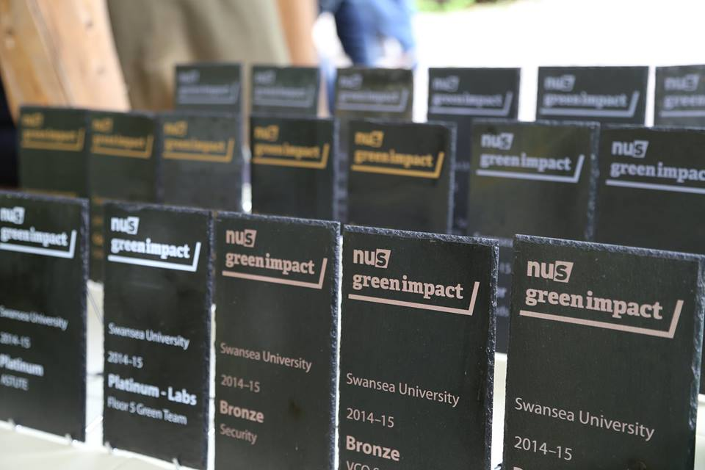
NUS will provide you with certificate templates, and a number of awards as agreed within the contract. If you would like to purchase any additional awards please contact your Green Impact Project Officer. Make sure that you provide the details of your award winners and place additional orders at 4-5 weeks in advance of your awards ceremony to ensure that they are in on time.
To reflect the ethos of the programme, the awards are entirely handmade, and took considerable trial and error order to achieve a successful process and design. The slates come from a restored worker’s cottage in Gower, Swansea and are cut to size using a hand guillotine or slating pliers as appropriate for the particular slate. Next comes power-washing to remove lichens and grime, and to highlight any fault or cracks before air-drying. The slates are packaged in reused wine boxes which are picked up from the local supermarket.

Publicity

Having a lot of publicity before and after the event helps ensure that it is a success. It will mean that you have a good turnout, everyone is recognised for their efforts, and creates a momentum upon which you can start recruitment for the following year of Green Impact.
By liaising with your communications/marketing department and the students’ union’s communications/marketing team (where relevant) you should be able to access pre-existing communication streams. You could produce posters or invites to use alongside email invitations and newsletter articles. Following the event, a write-up could appear on your website, in your magazine and/or newsletter. Departments will appreciate copies or access to relevant photographs. Remember this is your chance to show off what you’ve achieved so don’t miss out.

