Welcome to the first issue of the Green Impact Project in UCLH! The green Impact was started in 2016 part of the National Union of Students’ initiative to make organizations make more sustainable choices. UCLH joined Green Impact in 2016 and has since been part of this tremendous effort to save resources.
Number of teams signed up to 2018 Green Impact jumps to 10
Katie Jepson, the NUS Green Impact Coordinator for UCLH has reported a 200% jump in the number of teams that signed up to 2018’s Green Impact Project.
Last year we had just 5 teams take part and we managed to save over £7,000. With the current situation of the NHS we need to ensure that we are doing all we can to reduce financial waste, and Green Impact is certainly very promising in doing so.
_______________
September 2018

Success story: Hand therapy team

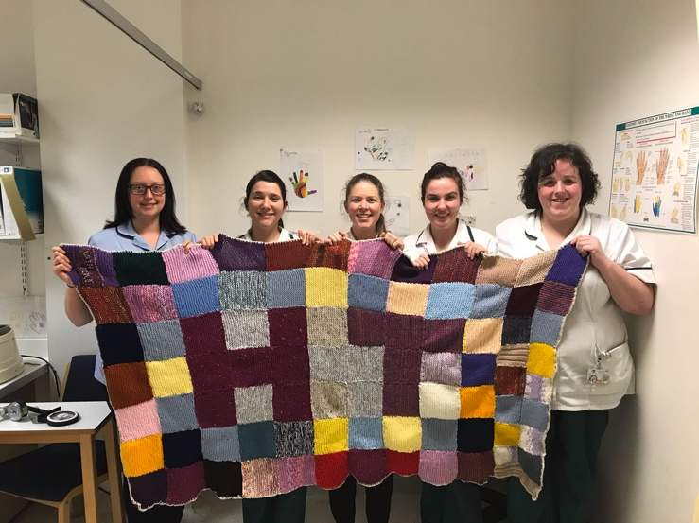
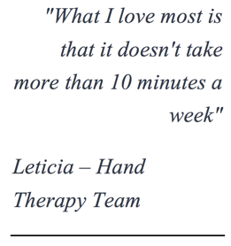
Aside: A knitted sweater made for a charity event by the team
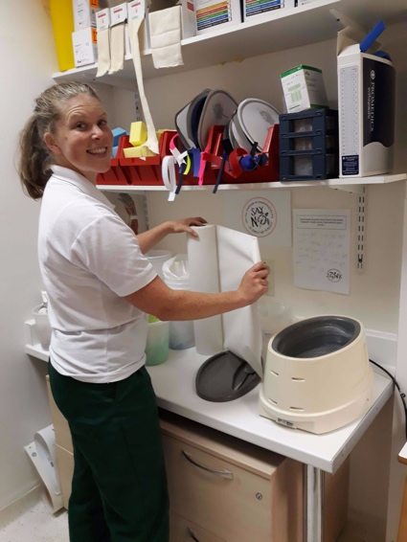
Aside:
Replacing plastic with tissue with a smile!

Green Dodos, (Green fingers) was the star of last year’s green Impact project. Also known as the Hand Therapy team, They formulated an ingenious way to reuse scraps and turn them into splints. They were then stored in reusable putty tubs. By replacing plastic with tissue paper, they have also tried to break free from plastic. It was definitely their innovation and dedication towards saving resources that earned them their prize.

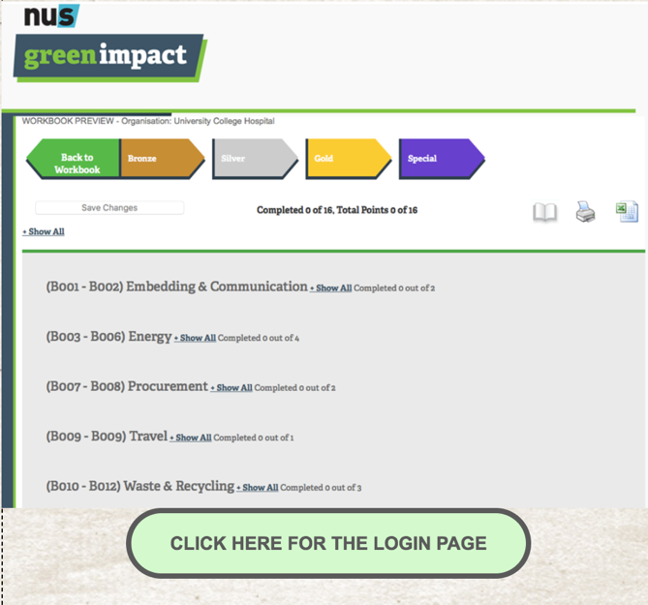

Our easy to use website!
Clear layout
All resources and materials available for download
Step by step instructions on each criteria
Easy to upload evidence portal
Hosting of multiple users in one team

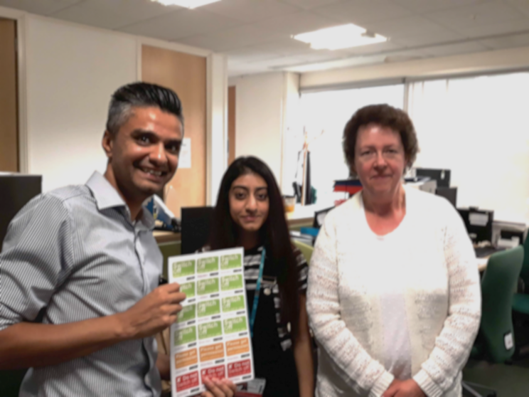
The ongoing success of the NathNac team
Green Impact around the UK
The University of Bedfordshire have signed NUS and People & Planet’s Fossil Fuel Declaration.
This comes in the wake of a series of high-profile divestment commitments in the past year – including Bath, Cardiff, Durham & Nottingham, as well as Ireland becoming the first nation in the world to make a fossil fuel divestment commitment.
The National Travel Health Network and Centre (NaTHNaC) in UCLH is one of the most recent teams to join UCLH. (Inset)
It has already made considerable strides in sustainability even with limited working area scope to do some innovative actions. With their office space just 5 desks of space, they have proven that you don’t need a huge team to make a substantial difference. Alex says “I always put the computers off for all the people in this team.”

The hand therapy team with energy saving stickers
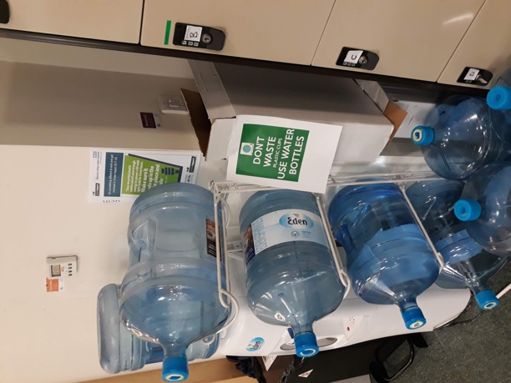
They have replaced all of their plastic cups (aside) with water bottles instead. The Hand Therapy team similarly has come up with a way to reduce paper wastage by using a single sheet to record the needs of the patients instead of the previous system of using individual papers each and every time.
“Don’t waste. Use water bottles!”
Did you know?
It takes 11 litres of water to make one A4 sheet of paper – enough for one dishwasher cycle!

Some activities to get going

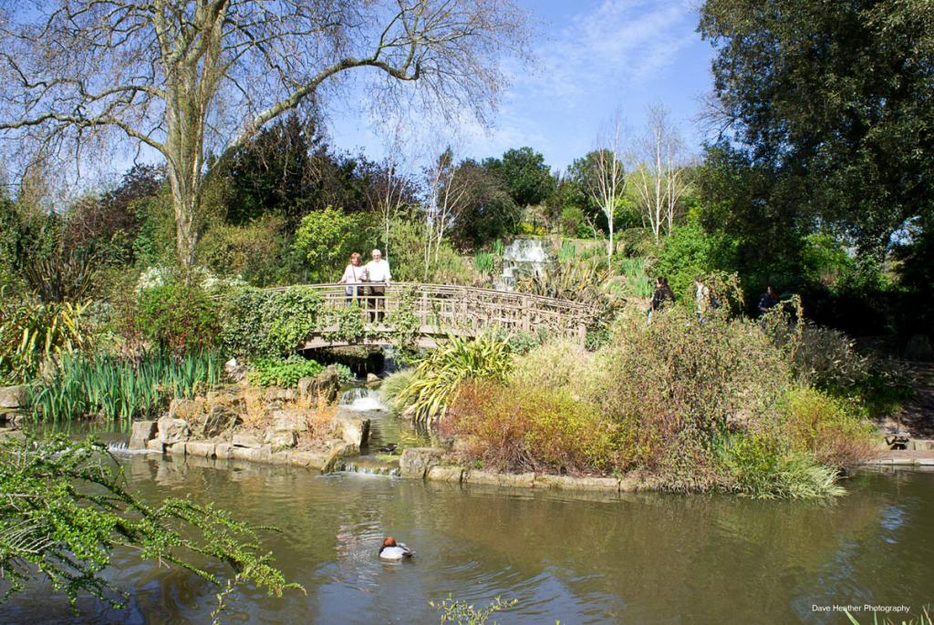
Organize a run in Regents Park.
It’s amazing how close this beautiful green landscape is to UCLH. Be sure to check out the graceful swans by the ponds, and the various colored irds.
Organize a sustainability themed bake sale
Use the opportunity to increase awareness about things like water waste.

Eat more plant based foods
A person switching to a plant based diet can feed 18 more people off the same piece of land! It also produces 50% less carbon dioxide on a plant based diet. Reducing your meat intake is the best method to reduce your carbon footprint!

It’s time to get rewarded for all the effort!!

Don’t forget to upload your evidence to get credit for all your hard work!
Dates for the audits: 22nd and 24th September 2018.

We would love to hear from you. Any questions? Comments? Want to write for the next issue?
Contact us!

